ITE-152 – HTML Tutorial
Note: to access an entry in the Table of Contents Control/Click on the item
If you are accessing this document through CANVAS then download the file to your hard drive in order utilize the functionality of the table of contents.

Table of Contents
CREATING A WEB PAGE 2
CREATING YOUR FIRST WEB PAGE 2
STEP 1: Open a text editor which is where you will type in the html code for your web page 2
STEP 2: Save the notepad file (webpage.txt) you just created so it can be viewed as a web page 3
STEP 3: View your web page in a browser 5
UNDERSTANDING THE STRUCTURE OF THE HTML IN A WEB PAGE 5
HTML TAG: <html> </html> 6
HEAD TAG: <head> </head> 6
FUN FACT 7
BODY TAG: <body> </body> 8
HEADER TAG: <h1> </h1> 8
PARAGRAPH TAG: <p> </p> 9
EXTERNAL LINKING 9
IMAGES 10
LISTS 11
CASCADING STYLE SHEETS (CSS) 11
UPLOAD FILES TO MYDRIVE 13
VALIDATION 13
APPENDIX 16
TEXTEDIT - MAC 16
NAMING YOUR WEB PAGE: RULES TO FOLLOW 16
MYDRIVE FILE UPLOAD INSTRUCTIONS 17

CREATING A WEB PAGE

To create a website, you use HTML, which stands for Hypertext Markup Language. This tutorial is a gentle introduction to HTML5, the latest version. An excellent resource is W3CSchools: HTML5 Tutorial

It is important that you complete all of the steps in this tutorial on your own computer. That is the best way to learn the material and successfully complete the Web Project Assignment in this Module.

CREATING YOUR FIRST WEB PAGE

STEP 1: Open a text editor which is where you will type in the html code for your web page
Open Notepad. To open notepad in Windows, click the windows icon in the lower left corner of the screen and then type "notepad." (For a Mac you will use “textEdit”. You will find the instructions for using and configuring textEdit in the APPENDIX under TEXTEDIT – MAC.)

Notepad is the text editor for Windows and textEdit is the text editor for Apple. Everywhere you see “notepad” in this tutorial you will substitute that with “textEdit” if you are using an Apple computer.

Once notepad is open, start typing (or copy and paste) the html code below into notepad:
<html>
<head>
<title>The title goes here</title>
</head>
<body>
<h1>This is a level one heading</h1>
<p>My first lovely paragraph. Wow. This is fun.</p>
<p>My second lovely paragraph. We can make paragraphs forever.</p>
<h2>This is a level two heading</h2>
<p>This is my third paragraph.</p>
</body>
</html>
Below is what you should now see in your Notepad file:
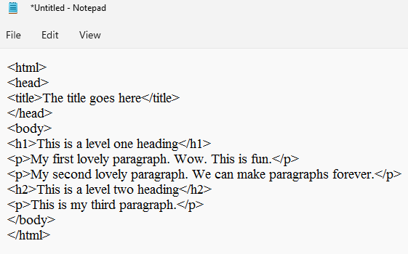
What did you just type into Notepad?
You just typed in HTML. This is the code a browser understands. Each line of code is generally inside something call a TAG in HTML. A tag begins with the name of the tag in brackets and ends with the name of the tag with a “/” in front of it. What you see between the tags is the content which you want to appear on your web page. The tags which you just typed into Notepad are color coded in these instructions so you can see the different types of tags you are using as well as where each tag begins and ends.

Save the Notepad file:
- Create a new folder on your desktop. Let’s call it “My First Web Page”.
- In Notepad you will click FILE and then SAVE AS
- Type “webpage” in the File Name: box at the bottom of the screen.
- Click SAVE. Make sure you are in the “My First Web Page” folder on your desktop before you click SAVE.

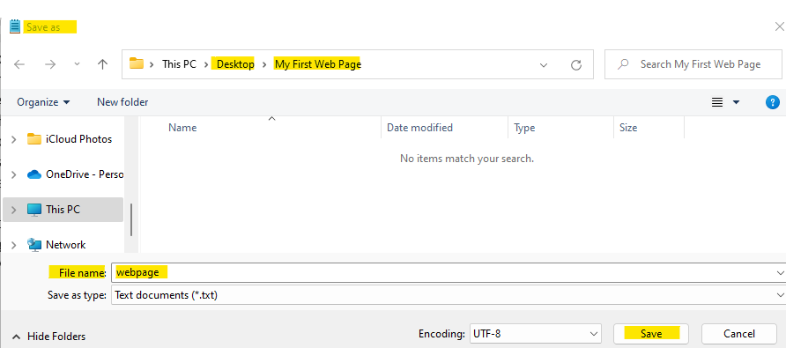

You will now see your webpage.txt file in your My First Web Site folder.
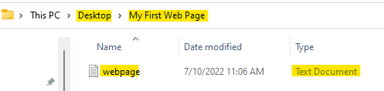

STEP 2: Save the notepad file (webpage.txt) you just created so it can be viewed as a web page

How to save your Notepad text file as an html file:

- In order to view your webpage.txt file as a web page you must save it again with a .html extension.
- Open the webpage.txt file in your My First Web Site Folder
- In Notepad you will click FILE and then SAVE AS (make sure to use SAVE AS, you don’t want to overwrite webpage.txt)
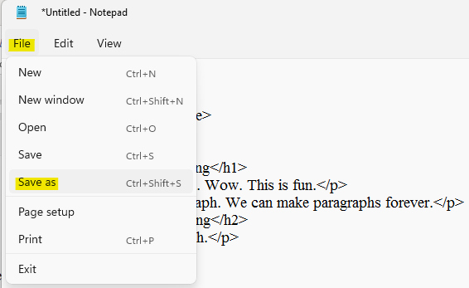
- Note that the “File name:” box already contains “webpage”
- The “Save as type:” box indicates this file will be saved as a .txt file. This is because it currently IS a .txt file.
- In the “File name:” box add “.html” at the end of “webpage”. You should have webpage.html. You do not need to do anything with the “Save as type:” box.
- Click SAVE
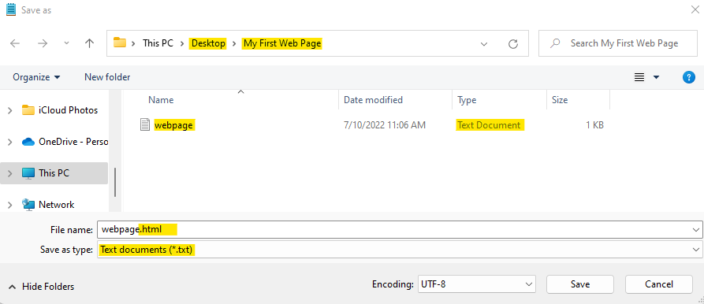
- You will now see two files in the My First Web Page folder. Both files are named “webpage” however one is a .txt file and the other is a .html file. The html file has an icon which represents my default browser and it has HTML Document as the type.
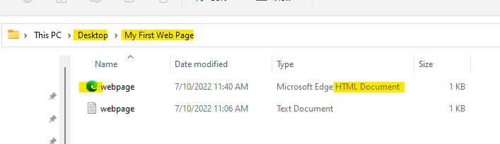

STEP 3: View your web page in a browser

The easiest way to preview your web site from your own computer (no one else can view it at this point) is to open webpage.html.

Open the “My First Web Page” folder on your desktop.

Note that the icon next to the file name “webpage” is for my default browser (Microsoft Edge). You will also note that under “Type” it indicates it is an HTML Document. This happened because you replaced the .txt extension with .html when you saved your notepad file.

Double click on the “webpage” html file in your “My First Web Page” folder.
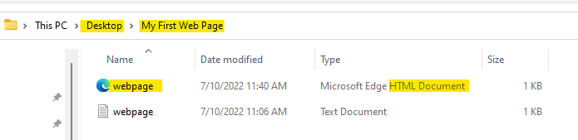

Here is what the web page currently looks like:

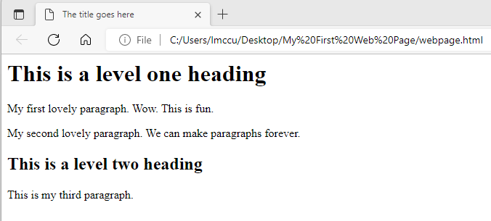

CONGRATULATIONS! You have just created your first web page using html!

UNDERSTANDING THE STRUCTURE OF THE HTML IN A WEB PAGE

To understand the structure to a web page let’s start with the html TAGS you will be using in this course. We will modify the html which is currently in webpage.html, which you created in the prior portion of the tutorial.

Remember – your best strategy to learn the material is to make the modifications as they appear in the tutorial, on your own computer.

Below is the html which is currently in webpage.html.

<html>
<head>
<title>The title goes here</title>
</head>
<body>
<h1>This is a level one heading</h1>
<p>My first lovely paragraph. Wow. This is fun.</p>
<p>My second lovely paragraph. We can make paragraphs forever.</p>
<h2>This is a level two heading</h2>
<p>This is my third paragraph.</p>
</body>
</html>

HTML TAG: <html> </html>

Every web page begins with <html> and ends with the </html>

The HTML tag contains the HEAD tag and the BODY tag.

<html>
<head>
<title>The title goes here</title>
</head>
<body>
<h1>This is a level one heading</h1>
<p>My first lovely paragraph. Wow. This is fun.</p>
<p>My second lovely paragraph. We can make paragraphs forever.</p>
<h2>This is a level two heading</h2>
<p>This is my third paragraph.</p>
</body>
</html>

HEAD TAG: <head> </head>

So what goes in the <head> tag? The title. The title is what appears in the tab, at the top of the browser window. I would like “My First Web Page” to appear in the browser tab. Replace “The title goes here” with “My First Web Page”

<html>
<head>
<title> My First Web Page </title>
</head>
<body>
<h1>This is a level one heading</h1>
<p>My first lovely paragraph. Wow. This is fun.</p>
<p>My second lovely paragraph. We can make paragraphs forever.</p>
<h2>This is a level two heading</h2>
<p>This is my third paragraph.</p>
</body>
</html>

Note: always make any modifications to the webpage.txt file. That is the file which contains the html which you can modify. Once you complete the modifications SAVE webpage.txt. To view it as an html file you will need to SAVEAS webpage.txt and change the .txt extension to .html. The system will ask if you want to replace webpage.html and the answer is yes. Webpage.html will now contain the changes you made.

This is what the web page looks like now. Notice “My First Web Page” is now in the browser tab.

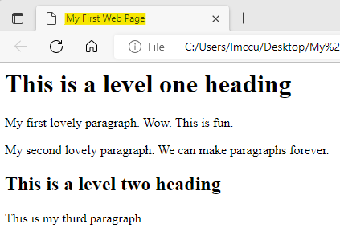

FUN FACT
To view the html used to create any web page, right click on the web page and select “View Page Source”. Note: this works for ALL web pages. The page source contains all of the html used to create the web page.

Below you can see the <title> tag in action on the NVCC.EDU web page.

Note that the content of the browser tab matches the content of the <title> tag.

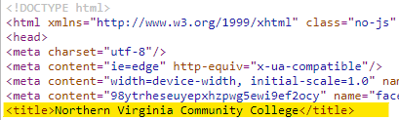



BODY TAG: <body> </body>

The html which creates the content of your web page is found between <body> and </body>

<html>
<head>
<title>The title goes here</title>
</head>
<body>
<h1>This is a level one heading</h1>
<p>My first lovely paragraph. Wow. This is fun.</p>
<p>My second lovely paragraph. We can make paragraphs forever.</p>
<h2>This is a level two heading</h2>
<p>This is my third paragraph.</p>
</body>
</html>

HEADER TAG: <h1> </h1>

h1, h2, h3 are examples of heading tags. Headings are usually used for, well, headings. What you want the heading to say goes between the <h1> and </h1> tags. The heading tags come in various sizes, from <h1>, <h2>, ... through <h6>. The <h1> heading will make text bold and large. <h2> is a little smaller, and so forth. <h6> headings are quite small.

Now, it may seem like a heading tag would go in the head, but it doesn't. Headings go in the body, just like everything else (except the title).

Let’s change the h1 tag from “This is a level one heading” to “My Summer Vacation”

Let’s change the h2 tag from “This is a level two heading” to “My Favorite Subject in School”

Don’t forget to make the modifications to webpage.txt, save webpage.txt so you don’t lose the changes. Then saveAs webpage.txt changing the .txt to .html.

<html>
<head>
<title> My First Web Page </title>
</head>
<body>
<h1>My Summer Vacation</h1>
<p>My first lovely paragraph. Wow. This is fun.</p>
<p>My second lovely paragraph. We can make paragraphs forever.</p>
<h2>My Favorite Subject in School</h2>
<p>This is my third paragraph.</p>
</body>
</html>

Here is what the web page looks like now:

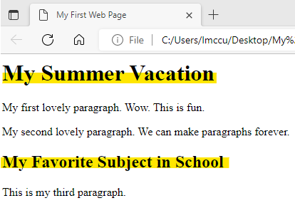

PARAGRAPH TAG: <p> </p>

Most of what you have to say goes in paragraphs, just like in real life. A paragraph starts with <p> and ends with </p>. What you want the paragraph to say goes between the <p> and </p>

Now it’s your turn:
Change the content of each of the 3 paragraphs below to anything of your choice. That way you can view webpage.html and make sure you are seeing the changes reflected there.
Don’t forget to make the modifications to webpage.txt, save webpage.txt so you don’t lose the changes. Then saveAs webpage.txt changing the .txt to .html.

<html>
<head>
<title> My First Web Page </title>
</head>
<body>
<h1>My Summer Vacation</h1>
<p>My first lovely paragraph. Wow. This is fun.</p>
<p>My second lovely paragraph. We can make paragraphs forever.</p>
<h2>My Favorite Subject in School</h2>
<p>This is my third paragraph.</p>
</body>
</html>

EXTERNAL LINKING

If you want to link to another web site, the link code should include the entire URL, as follows:
This html statement:
For a great place to buy books, visit <a href="http://www.amazon.com">Amazon.</a>

Looks like this on the web page:

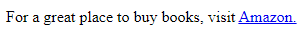

IMAGES

Adding images can really spice up a web page. Images which appear on web pages are typically .jpg, .gif, or .png files. These three popular compression formats are universally recognized by browsers. Do not use another format, such as .bmp.

Please make sure you either own the image or have permission from the owner to use the image. Here are a few web sites that have some free images available for your use:
- unSplash
- GettyImages
- MorgueFile

To download an image, place your cursor over the image, right-click, and select "Save Picture As" or "Save Image As." Save the image in the same folder as the web page on which you want the image to appear. The following code will add an image to your web page:
<img src="imagename.jpg" alt="alternative text">

Replace imagename.jpg with the name of your image file.

The alt attribute provides alternative text for those users who cannot or prefer not to view images.

For example, if you want an image of a turtle to appear on your web page, the code might look like this

<img src="turtle.jpg" alt="Pretty Box Turtle">

The image code will work only when the image file and the html file are in the same folder. If the files are in different folders, you must use an absolute path, which is beyond the scope of this tutorial.

If the image does not appear on your web page, check the following:

- Is the filename in the image code exactly the same as the actual filename? Beware: sometimes you don't see the entire filename on your computer.
The Windows operating system typically hides file extensions. To see your file extensions, open File Explorer: View > check File Name Extensions. For older versions of Windows: File Explorer: Organize > Folder and Search Options > View, then uncheck "Hide extensions for known file types."
To see your file extensions using the Mac operating system, choose Finder > Preferences, then click Advanced. Select or deselect “Show all filename extensions.”

- Are both the html file and the image file in the same folder
- Never start the image filename with c:/ or e:/ or any other drive. This may work on your local computer, but when a user on another computer tries to view the web page, the image will not appear as the files are not on the user’s hard drive.

LISTS

Let's make some lists. First we'll make an ordered list; this is a list that has numbers. Here's how:
<html>
<head>
<title>List Example</title>
</head>
<body>
<h1>Shopping List</h1>
<ol>
<li>Milk</li>
<li>Sugar</li>
<li>Candy</li>
<li>Bread</li>
</ol>

</body>
</html>
Give it a try. Copy the above code into a new Notepad file, save it as shop.txt so you don’t lose the original html. Then saveAs shop.txt changing the .txt to .html (shop.html).

Open shop.html" in a browser and see how it looks.

You might have figured out that the "ol" in the code stands for "ordered list." The "li" in the code stands for "list item." Notice, every beginning tag has an ending tag.

Your turn:
Add an h2 tag which says “Unordered List”
Next add the html for an unordered list (bullets): replace the <ol> tag with <ul>, and the </ol> tag with </ul>. Yes, "ul" stands for "unordered list."

View shop.html, in a browser, to make sure have properly added the h2 tag, an ordered list, and an unordered list to the shop.html web page.

CASCADING STYLE SHEETS (CSS)

Cascading Style Sheets (CSS) add style to your website. With external CSS you create a separate file which contains all of the html styling tags you would like to apply to your web page.

The CSS file you create (using Notepad) must have a .css extension. The HTML file (.html extension) contains the content and the structure (the tags), while the CSS file says how the page should look.

The simplest approach to styling is to style HTML tags. Here's how to create an external style sheet that styles tags. The name of the style sheet must end with .css. Let's call it styles.css. Notice there are no html tags in a style sheet. Instead, we say how we would like each tag to be styled by listing properties and values. Each property is followed by a colon. Below is the CSS style sheet you will create now, and then later use for the project in this module.

Follow the steps below to create the cascading style sheet (styles.css)

Open a new Notepad file and copy/paste the code below into Notepad. Save the file as styles.txt. (Make sure you save it in your “My First Web Page” folder).

Next, SAVEAS styles.txt and change the .txt extension to the .css extension. This is the same process you have been using to create the html files. Only this time you are creating a .CSS file.

NOTE: you will use this styles.css file in the project for this module so don’t delete it!

body {
background-color: powderblue;
}

h1 {
color: red;
}

h2 {
color: white;
text-align: center;
border-style: double;
border-color: blue;
background-color: red;
width: 200px;
}

p {
font-family: verdana;
font-size: 20px;
color: green;
}

ol {
color: yellow;
font-family: cursive;
}

The above style sheet says:
- Make the background color of the web page powder blue.
- Make every level 1 heading have the text the color red.
- Make every level 2 heading have:
  - header text white
  - content of header centered
  - double line border around header
  - border color blue,
  - header background color red
  - width of the header 200 pixels
- Make the text for every paragraph green with the font verdana and a font size of 20 pixels.
- Make the text of every ordered list yellow with the font cursive.

You have now created a cascading style sheet and saved it as styles.css. To link the css file to your web page add <link href="styles.css" rel="stylesheet"> to the head section in the html file.

<head>
<title>The title goes here</title>
<link href="styles.css" rel="stylesheet">
</head>

The Cascading Style Sheet (styles.css) is how you add color, change fonts, add borders etc. to a web page. If you were creating multiple web pages you would add the <link href="styles.css" rel="stylesheet"> to the <head> tag on every page. This will cause all tags to be styled the same way on all pages which adds consistency throughout the web site.

UPLOAD FILES TO MYDRIVE

The final step is to upload all files associated with your web site to the MYDRIVE server provided by NVCC. A web page must be uploaded to a web server in order to be viewed by the outside world. You will find the instructions for uploading files in the APPENDIX under MYDRIVE FILE UPLOAD INSTRUCTIONS.

VALIDATION

You may think if your web page shows up in the browser, the code is correct. Not so. Browser software is designed to attempt to correct coding errors. Incorrect code may appear the way you intended in one browser, may appear odd in another browser, and may not appear at all in a third browser.

There's an easy way to find out if your code is correct. Validate! The World Wide Web Consortium offers a nifty validator. It's at http://validator.w3.org/.

Now, there's one little catch. You have to tell the validator what version of html you're using, so it knows what to validate.

That's easy, just add a DOCTYPE at the top of your web page. You also must add language information to the html tag, as well as a meta tag which indicates the character set.

<!DOCTYPE html>
<html lang="en">
<head>
<title>The title goes here</title>
<meta charset="utf-8">
<link href="styles.css" rel="stylesheet">
</head>
<body>
<h1>This is a level one heading</h1>
<p>My first lovely paragraph. Wow. This is fun.</p>
<p>My second lovely paragraph. We can make paragraphs forever.</p>
<h2>This is a level two heading</h2>
<p>This is my third paragraph.</p>
</body>
</html>
Do not try to type this. Just copy and paste the section in red above, at the top of the web page you're making in Notepad. Don't forget to save the file again.

The DOCTYPE tells the validator what version of HTML you are using. There are several different versions of html. We're learning HTML5.

Now you're ready to validate. Here's the link again: http://validator.w3.org/. When you get to the W3C validation page, click the tab that says "Validate by File Upload." Browse to the correct file, then click the "Check" button.

If the code validates, you'll see "Document checking completed. No errors or warning to show." on a green background. Green is good. If the code does not validate, you'll see "Error found while checking this document as HTML5! " on a red background. Red is bad.
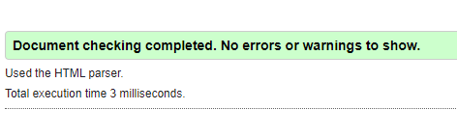
If your code does not validate, the validator will tell you what is wrong. Read the feedback from the validator, change your code in Notepad, save, then validate again.

The validator generates error messages that are usually pretty helpful, but because of the way it parses documents, occasionally its feedback is cryptic. You'll get used to this, but here are some tips to help you get started:

Validation errors cascade. Don't get discouraged if you see you have 36 errors in your document! Fix the first one, then validate again. This will often fix many of the following errors, especially those that pertain to the structure of the document.

The validator may object to code which is correct, but is in the wrong location. For example
<!DOCTYPE html>
<html lang="en">
<head>
<title>The title goes here</title>
<meta charset="utf-8">
</head>
<body>
<h1>This is a level one heading</h1>
<p>This is BAD CODE EXAMPLE. Don't copy it</p>
<p>My second lovely paragraph. </p>
</body>
<h2>This is a level two heading</h2>
<p>This is my third paragraph. </p>
</html>
The above code generates the following validation error:
 Line 19, Column 4: Stray start tag h2.
<h2>This is a level two heading</h2>
There is nothing wrong with the code for the h2 statement; the validator is objecting to its location. The previous statement, the </body> statement, is in the wrong place. The closing body tag must come after all statements and right before the </html> tag.

APPENDIX

TEXTEDIT - MAC
MAC Users: Set TextEdit Preferences as shown below:
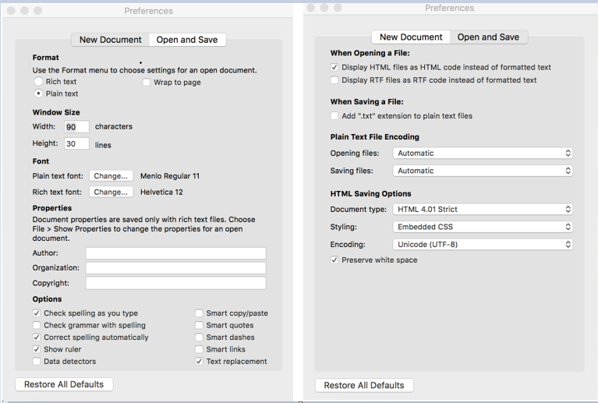

NAMING YOUR WEB PAGE: RULES TO FOLLOW

Naming a web page correctly is easy if you follow these three rules:
- No spaces
Spaces in filenames can confuse browsers and email programs. Browsers usually substitute "%20" for a space. Email programs sometimes cut off URLs after a space. If you want to use a space for clarity, use a hyphen instead. For example,

"onion recipe.html"
becomes
"onion-recipe.html"

- No capitals
Capitals matter. You're probably creating your first web page in a Windows operating system environment. If so, Windows is pretty lax about file names. But once you're done creating your page, and you upload it to a server (so that Aunt Tilly in Iowa can see it), the server may be using a different operating system, like Unix or Linux. Unix and Linux care about capitals. MyFile.html is a totally different file than myfile.html in a Unix or Linux environment.
The file extension is .html (that's dot html)
Extensions matter. Your web page extension must be either .htm or .html. It doesn't matter which, but you've got to be consistent.

MYDRIVE FILE UPLOAD INSTRUCTIONS

Open your web browser and go to https://myDrive.nvcc.edu

Enter your myNOVA username and password (same credentials used for Canvas), then click the Sign in to MyDrive button.

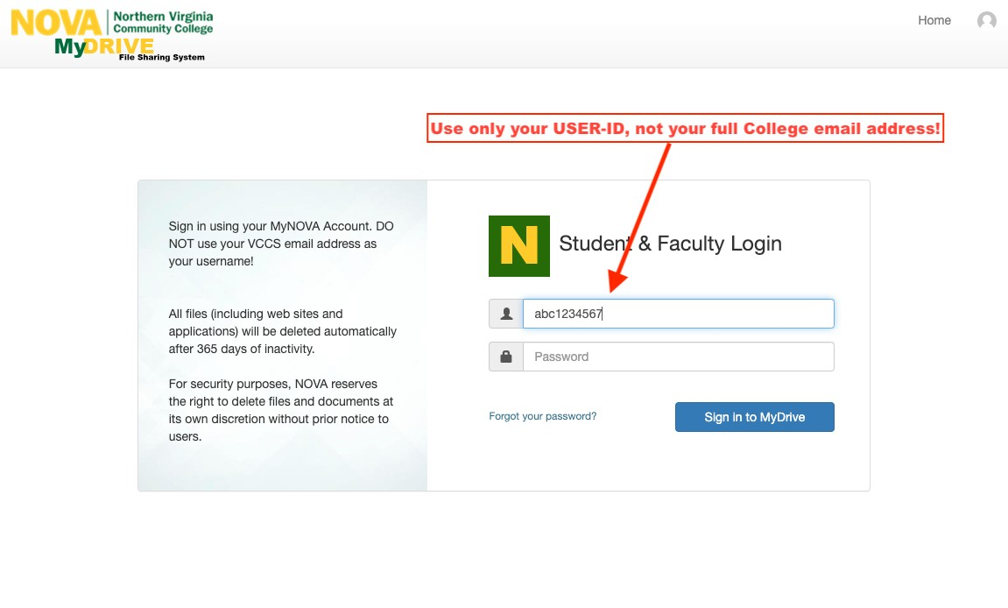
Same username you use to log into Canvas
Once you have successfully logged in, you will see the NOVA myDrive home page. Click on “My Student Web Folder”

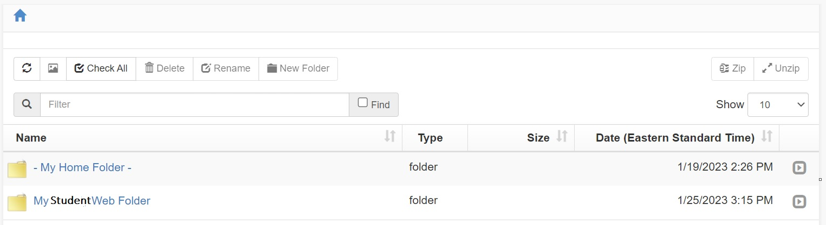

Click Add files. This will bring up File Explorer.

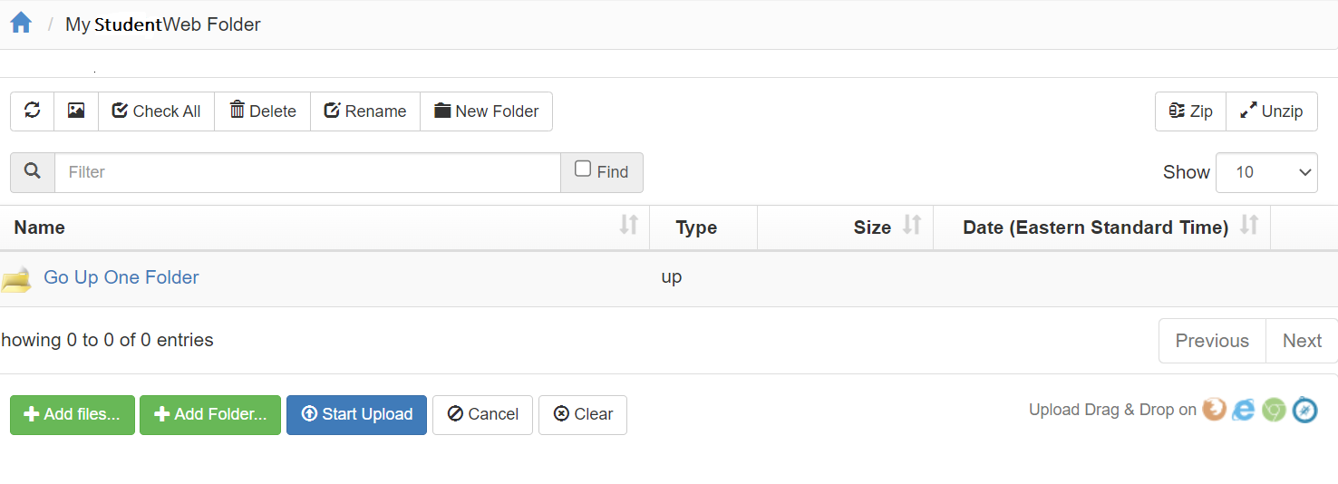

Navigate to the location where you have your files saved.
Select all files you want to upload to MyDrive. Click Open in File Explorer.

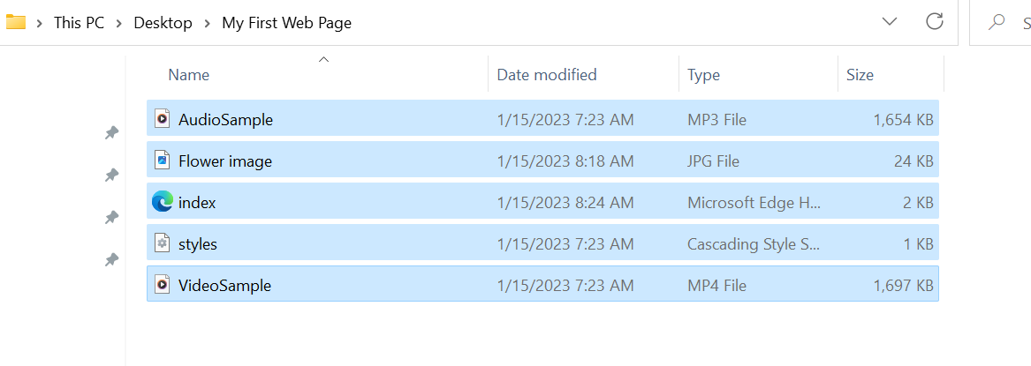

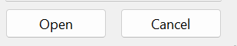

The files will now appear in the window BELOW the Add Folder button. To add these files to myDrive’s “My Student Web Folder”, click Start Upload. Note: the files listed are only examples you will upload YOUR files.

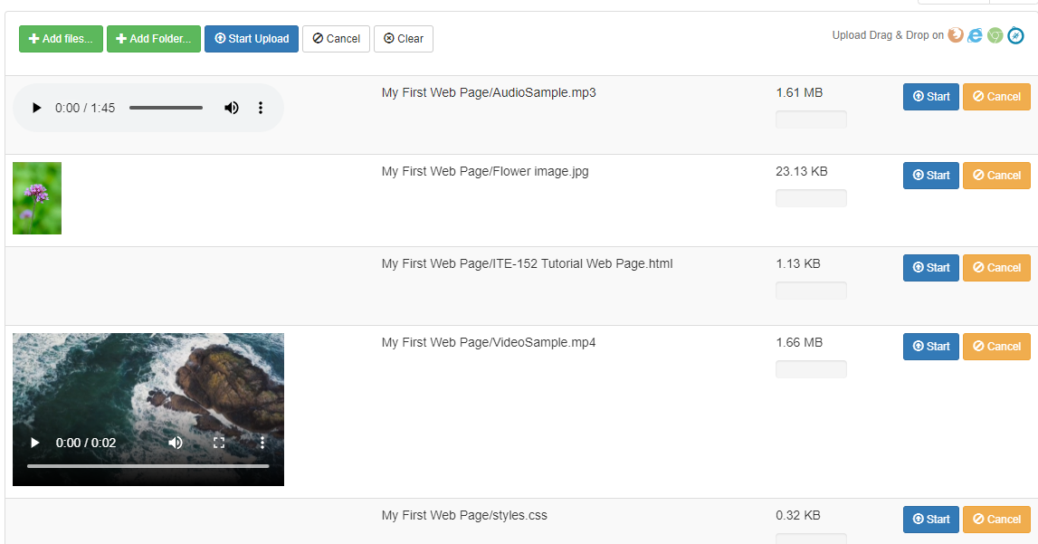

You will know the files are uploaded to myDrive when the files appear ABOVE the Add Files button.

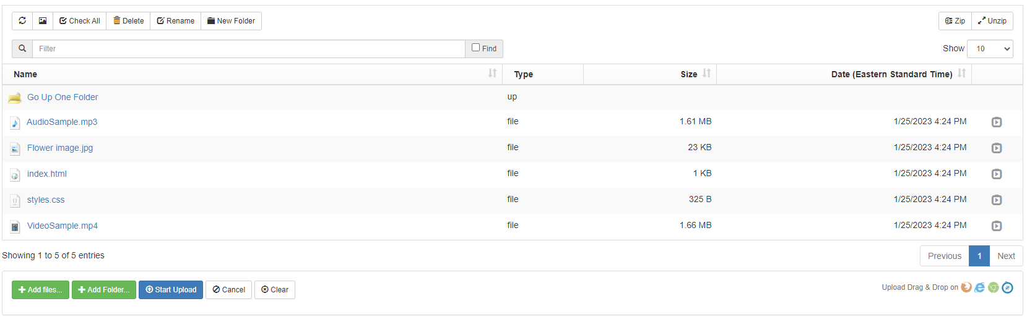

You will submit the URL to your web site via the submission link in Canvas.

Here is the format of the URL. https://student.nvcc.edu/Username (Username will be replaced with your MyNOVA username)
- To test your URL open a new browser window and enter the URL. This will render your web page(s) so you can make sure it is working as expected. Keep in mind…whatever you see using your URL is what the instructor will also see.

